**Index**

|  |  |  |
| --- | --- | --- |
| **Sr. No** | **Title** | **Page No.** |
|  | **Chapter - 1** |  |
| 1 | 1.1: Background of the Project with Existing Scenario |  |
| 2 | 1.2: The Objective of Project and Problem Statement |  |
| 3 | 1.3: Scope, Advantages and Disadvantages of Project |  |
| 4 | **Chapter - 2**  **Survey of Technologies used During the Project Implementation** |  |
|  | * **Chapter - 3 Requirements & Analysis** |  |
| 5 | 3.1: Problem Statement |  |
| 6 | 3.2: Feasibility Statement |  |
| 7 | 3.3: Requirement Specification |  |
| 8 | 3.4: Software Requirements |  |
| 9 | 3.5: Planning & Scheduling |  |
| 10 | **Chapter - 4 System Design** |  |
|  | **Chapter - 5 Implementation & Testing** |  |
| 11 | 5.1: Algorithms & Flowchart along with Major Modules of the Project |  |
| 12 | 5.2: Testing Approach |  |
| 13 | 5.3: Test Case with Test Result |  |
|  | **Chapter - 6 Results & Discussion** |  |
| 14 | 6.1: Summary of Test Reports |  |
| 15 | 6.2: Discussion |  |
|  | **Chapter - 7 Conclusion** |  |
| 16 | 7.1: Conclusion of the Project |  |
| 17 | 7.2: Limitation of the Project |  |
| 18 | 7.3: Future Scope of the Project |  |
| 19 | **Reference** |  |
| 20 | **Annexure** |  |

**Chapter – 1**

* 1. **Background of the Project with existing scenarios**

**Background of Project**

The Linkers project was conceived as a response to the evolving landscape of digital communication and social media engagement. In today's interconnected world, individuals, businesses, and organizations rely heavily on social media platforms to disseminate information, connect with their audience, and promote their products and services. However, the process of managing and optimizing digital content across multiple platforms can be complex and time-consuming, requiring users to navigate through various interfaces and tools to achieve their desired outcomes.

Recognizing the growing demand for a streamlined solution that simplifies the generation of links and codes for social media platforms, the Linkers project was conceptualized with a clear vision: to empower users with an intuitive and efficient toolset for managing their digital presence. By leveraging the latest technologies and best practices in web development, the Linkers platform aims to revolutionize the way users create, customize, and share links and codes across different social media channels.

**Existing Scenarios**

Before the development of Linkers, users often faced several challenges when generating links and codes for social media platforms. Some common scenarios observed in existing practices include:

* Manual Link Generation: Users had to manually construct links for their social media profiles or content, which was time-consuming and prone to errors. This process involved navigating through multiple interfaces and copying and pasting various components to create a functional link.
* Limited Code Generation Options: Users lacked access to comprehensive tools for generating QR codes, anchor codes, and other types of codes for their social media presence. As a result, they had to rely on third-party websites or software with limited functionalities.
* Security Concerns: Users expressed concerns about the security and reliability of third-party services for generating links and codes. Trusting external platforms with sensitive data raised apprehensions about privacy, data breaches, and potential misuse of personal information.
* Lack of Customization: Existing solutions offered limited options for customizing links and codes according to user preferences. Users desired more flexibility in designing and branding their digital assets to align with their unique identities and branding strategies.
* Authentication Requirements: Certain advanced features, such as premium link generation and code customization, required users to authenticate their identities through complex registration and login processes. This added friction to the user experience and deterred some users from accessing these features.
* By addressing these objectives, Linkers endeavours to become the go-to platform for individuals, businesses, and organizations seeking efficient and reliable solutions for managing their digital presence on social media.
  1. **Background of the Project with existing scenarios**

**Objective of Project**

* The primary objective of the Linkers project is to address the existing gap in the market for comprehensive and user-friendly platform that offers a diverse range of features for managing digital content on social media platforms. Through extensive research and development, it was identified that while there are numerous tools and services available for generating links, QR codes, and anchor codes individually, there is a lack of a unified solution that integrates all these functionalities into a single platform.
* The Linkers project aims to fill this void by providing users with an all-in-one solution for creating, customizing, and sharing links, QR codes, and anchor codes across various social media channels. By consolidating these features into a single, intuitive interface, Linkers seeks to streamline the process of managing digital content and empower users with the tools they need to enhance their online presence and engagement.

**Problem Statement**

* Existing solutions often require users to navigate through multiple interfaces and tools, leading to inefficiencies, confusion, and frustration. Moreover, the lack of integration between different tools and services makes it challenging for users to maintain consistency and coherence in their online branding and communication efforts.
* The Linkers project seeks to address these challenges by providing users with a unified platform that simplifies the process of creating and customizing links, QR codes, and anchor codes for social media platforms. By offering a comprehensive suite of features in a single, user-friendly interface, Linkers aims to empower users with the tools they need to optimize their digital presence and achieve their marketing objectives effectively.
  1. **Scope, Advantages and Disadvantages of Project**

**Scope of Project**

* The scope of the Linkers project encompasses the development and deployment of a comprehensive web-based platform that offers a range of features for managing digital content on social media platforms. Key components of the project include:
* Link Generation: Users can create custom links for sharing content on social media platforms such as Instagram, Facebook, Twitter, Gmail, and more.
* QR Code Generation: The platform allows users to generate QR codes for their links, enabling offline sharing and promotion.
* Anchor Code Generation: Users can generate anchor codes for embedding links in HTML documents, facilitating website integration.
* User Authentication: The platform includes user authentication functionality to secure premium features and user data.
* Customization Options: Users can customize the appearance and behavior of their links and QR codes to align with their branding and messaging.
* Analytics and Reporting: Linkers provides users with insights into link performance and engagement metrics to track the effectiveness of their campaigns.

**Advantages of Project**

* Convenience: Linkers offers a one-stop solution for link, QR code, and anchor code generation, streamlining the process of managing digital content.
* Time-Saving: By consolidating multiple functionalities into a single platform, Linkers saves users time and effort that would otherwise be spent navigating between different tools and services.
* Enhanced Branding: The customization options available in Linkers empower users to maintain consistency in their branding across various digital channels, enhancing brand recognition and credibility.
* Data-driven Insights: With built-in analytics and reporting features, Linkers provides users with valuable insights into the performance of their digital campaigns, enabling informed decision-making and optimization.
* User Authentication: The inclusion of user authentication ensures that premium features are accessible only to authorized users, enhancing security and privacy.

**Dis-advantages of Project**

* Learning Curve: Users may require some time to familiarize themselves with the platform's features and functionalities, particularly if they are new to digital marketing tools.
* Dependency on Internet Connectivity: As a web-based platform, Linkers relies on internet connectivity for access and functionality, which may pose challenges in areas with limited or unreliable internet access.
* Compatibility Issues: While efforts will be made to ensure compatibility across different devices and browsers, there may still be instances of compatibility issues or limitations on certain platforms.
* Privacy Concerns: Users may have concerns about the privacy and security of their data when using online platforms, necessitating robust data protection measures and compliance with privacy regulations.

**Chapter – 2**

**Survey of Technologies used During the Project Implementation**

* In the project implementation phase, various technologies were surveyed and selected based on their suitability for different aspects of the development process. Here's an overview of the technologies used:
* **Frontend Technologies:**
  + HTML (Hypertext Markup Language):
* HTML5, the latest version of HTML, was utilized to create semantic and structured web pages, ensuring accessibility and compatibility across different browsers and devices.
  + CSS (Cascading Style Sheets):
* Advanced CSS features such as Flexbox and Grid layouts were employed to build responsive and visually appealing designs. CSS preprocessors like Sass or LESS might have been used to enhance maintainability and code organization.
  + JavaScript:
* Modern JavaScript frameworks/libraries like React.js, Vue.js, or AngularJS might have been incorporated to facilitate component-based development, state management, and improved code organization. Additionally, asynchronous programming techniques with Promises or async/await were employed for efficient handling of asynchronous tasks.
* **Backend Technology:**
  + MySQL:
* MySQL was chosen as the backend database management system (DBMS) for storing and managing structured data efficiently. It offers robust features for data manipulation, retrieval, and maintenance, making it suitable for a wide range of applications.
* **Version Control System:**
  + Git:
* Git, along with platforms like GitHub, was utilized for version control, collaborative development, and code repository management. GitHub provided additional features such as issue tracking, project management tools, and pull request workflows, enhancing collaboration and code review processes. Advanced Git features like branching, merging, and rebasing were leveraged to streamline development workflows and maintain code quality. Continuous integration (CI) and continuous deployment (CD) pipelines might have been integrated with GitHub Actions to automate testing, build, and deployment processes directly from the GitHub repository.
* **Other Supporting Technologies:**
  + APIs (Application Programming Interfaces):
* RESTful APIs were designed and implemented to expose backend functionality, allowing seamless communication between the frontend and backend components. Authentication mechanisms such as OAuth 2.0 or JSON Web Tokens (JWT) might have been employed to secure API endpoints and control access to resources.
  + Web Servers:
* Web servers like Apache or Nginx could have been utilized to host the web application and serve HTTP requests from clients.
* Overall, the selection of these technologies was driven by considerations such as scalability, performance, ease of development, community support, and compatibility with project requirements and objectives.

**Chapter – 3 Requirements & Analysis**

**3.1 Problem Statement**

* The Linkers project addresses the following key challenges:
* Fragmented Link Generation Process: Currently, users often rely on separate tools or manual methods for generating links, QR codes, and anchor codes across different social media platforms and messaging services. This fragmented approach leads to inefficiencies and inconsistencies in the link management process.
* Lack of Unified Platform: There is a lack of a unified platform that offers comprehensive link generation functionalities for multiple social media platforms and messaging services. Users struggle to find a single solution that caters to their diverse link generation needs, leading to frustration and time wastage.
* Security and Privacy Concerns: Many existing link generation tools may compromise user privacy or expose sensitive information due to inadequate security measures. Users are hesitant to use such tools for generating links and QR codes, especially for sharing personal or confidential content.
* The stakeholders involved in the Linkers project include:
* End Users: Individuals and organizations who utilize the link generation platform to create and manage links, QR codes, and anchor codes for various purposes, including social media marketing, content sharing, and digital communication.
* Developers and Designers: The team responsible for designing, developing, and maintaining the Linkers platform. This includes frontend developers, backend developers, UI/UX designers, and system administrators who collaborate to ensure the platform's functionality and performance.
* Business Owners and Administrators: Entities or individuals who own and operate the Linkers platform, overseeing its strategic direction, business model, and revenue generation strategies. Business owners are invested in maximizing user engagement, satisfaction, and profitability.
* Third-Party Service Providers: Providers of external services and APIs integrated into the Linkers platform, such as social media APIs, analytics services, and authentication providers. These stakeholders play a crucial role in enabling key functionalities and enhancing the user experience.

**3.2 Feasibility Study**

**3.3 Requirement Specialization**

* The Linkers project aims to meet the diverse needs of users by providing a comprehensive set of features and functionalities. The following requirements have been identified based on user feedback and project objectives:
* User Authentication and Authorization:
  + Users should be able to create accounts and log in securely to access the platform's features.
  + Authentication mechanisms should ensure user privacy and protect sensitive information.
  + Role-based access control should be implemented to manage user permissions and privileges.
* Link Generation and Management:
  + Users should be able to generate links for various social media platforms and messaging services, including Instagram, Facebook, Twitter, Gmail, and WhatsApp.
  + The platform should support dynamic link parameters, allowing users to customize link URLs, titles, descriptions, and other metadata.
  + Users should have the ability to manage and organize their generated links, including editing, deleting, and categorizing them for easy retrieval.
* QR Code Generation:
  + Users should be able to generate QR codes corresponding to their generated links for offline sharing and scanning.
  + QR codes should be customizable in terms of size, color, error correction level, and branding options.
* Anchor Code Generation:
  + Users should have the option to generate anchor codes or anchor tags for embedding links within HTML content, such as webpages or email newsletters.
  + Anchor codes should support custom attributes and styling options for seamless integration with existing content.
* Premium Features and Subscriptions:
  + The platform should offer premium features such as detailed analytics, link tracking, A/B testing, and advanced customization options.
  + Users should have the option to subscribe to premium plans with tiered pricing based on feature availability and usage limits.

**3.4 Software Requirements**

* Web Browser:
  + Users will need a modern web browser such as Google Chrome, Mozilla Firefox, Apple Safari, or Microsoft Edge to access the Linkers project website.
  + The browser should be updated to the latest version for optimal performance and compatibility with web standards.
* Internet Connection:
  + A stable internet connection is required to access the Linkers project website and its features.
  + High-speed broadband or cellular data connectivity is recommended for smooth browsing and interaction.
* JavaScript Enabled:
  + Users must have JavaScript enabled in their web browser settings to enable dynamic and interactive functionalities on the Linkers project website.
  + JavaScript is essential for features such as form validation, DOM manipulation, and asynchronous data loading.
* Text Editor or IDE (Optional):
  + Users interested in exploring or modifying the project source code may use a text editor or integrated development environment (IDE) for code editing.
  + Recommended text editors/IDEs include Visual Studio Code.

**3.5 Planning & Scheduling**



* The choice of Software Development Life Cycle (SDLC) model depends on the specific
* requirements, complexity, and nature of the project. Based on the scope of the Linkers
* Project described, an Agile SDLC model would be a suitable choice. Here's why:
* **Flexibility and Iterative Development:** Agile allows for flexibility and iterative development, enabling you to adapt to changing requirements and incorporate user feedback at different stages. This approach is particularly beneficial for projects where requirements are not fully known or may evolve over time.
* **Continuous User Involvement:** Agile emphasizes continuous collaboration with stakeholders and end-users. Given that the Linkers Project involves user interactions and experience, having regular feedback loops ensures that the product aligns closely with user expectations and needs.
* **Early and Incremental Delivery:** Agile promotes the delivery of working software in small, incremental iterations. This approach allows you to demonstrate functionality early and frequently, providing stakeholders with tangible progress updates. For a project like Linkers, where user interaction and feedback are vital, this incremental delivery can lead to faster validation of concepts and features.
* **Quick Adaptation to Changes:** Agile methodologies, such as Scrum or Kanban, are well-suited for accommodating changes even in the later stages of development. As user needs or market demands shift, Agile allows your team to quickly adapt the project scope and priorities without causing significant disruptions.
* **Improved Quality:** Agile practices, including continuous testing and integration, contribute to better software quality. By addressing issues promptly and conducting regular testing, you can ensure a reliable and stable product, which is crucial for a project involving user interactions like the Linkers Project.
* Given these factors, Agile offers the right balance of flexibility, user involvement, and
* adaptability, making it a suitable choice for the Linkers Project. However, it's essential to
* assess your team's expertise, project size, and specific requirements before finalizing the
* SDLC model.

**Chapter – 4**

**System Design**

**4.1 Flowchart**

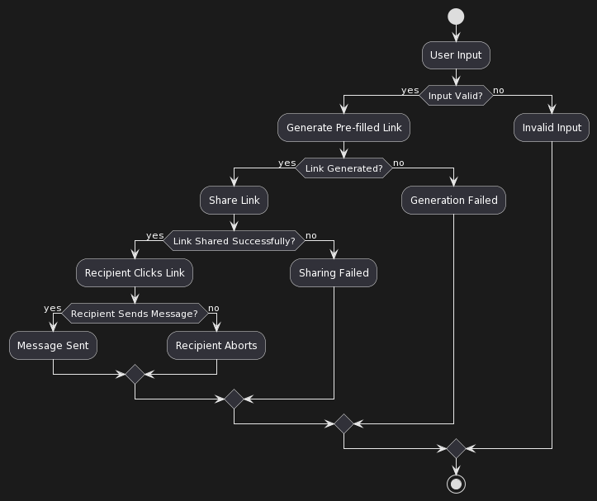

* **Explanation of the Flowchart of Linkers’ Project**
* **Share Link / Generate Pre-filled Link:**
* The user is asked if they want to share a link or generate a pre-filled link. If they choose to share a link, they are asked if the link has been generated. If they choose to generate a pre-filled link, they are asked if the link generation was successful.
* **Link Generated? / Link Generated?:**
* If the user indicates that the link has been generated, they are then asked if the link was shared successfully. If the user chose to generate a pre-filled link, they are asked if the pre-filled link generation was successful.
* **Link Shared Successfully? / Recipient Clicks Link:**
* If the link was shared successfully, the user is then asked if the recipient clicked the link. If the pre-filled link was generated successfully, the user is asked if the recipient sent a message.
* **Recipient Clicks Link / Recipient Sends Message?:**
* If the recipient clicked the link, the user is asked if the recipient sent a message. If the recipient sent a message, the process ends. If the recipient did not click the link, the process ends as well.
* **User Input:**
* Throughout this process, the user is asked to input their responses. If the user enters an invalid input, they are asked to input again. If the generation fails at any point, the user is asked to input again.

**4.2 Use case**

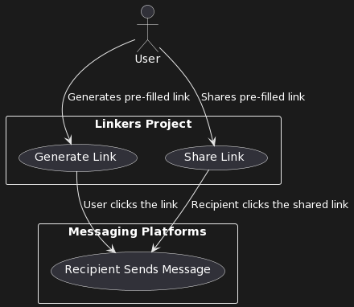

* In this diagram:
* User (U): Represents the user of the Linkers Project.
* Generate Link: Use case where the user generates a pre-filled link.
* Share Link: Use case where the user shares the generated link.
* Recipient Sends Message: Represents the action taken by the recipient when they send the message after clicking the pre-filled link.
* The arrows indicate the flow of events. Users generate pre-filled links using the "Generate Link" use case. They can then share these links, and recipients, represented by "Recipient Sends Message," interact with the messaging platforms after clicking the shared links.

**4.3 Data flow diagram**

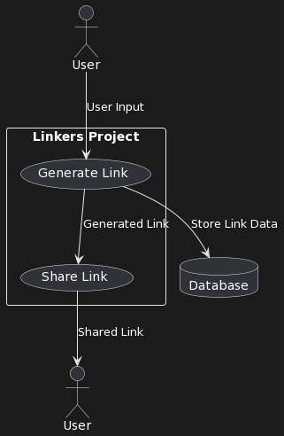

* In this DFD:
* User (U): Represents the external entity interacting with the system.
* Generate Link: Represents the process of generating a pre-filled link.
* Share Link: Represents the process of sharing the generated link.
* Database (DB): Represents the data storage component where link data is stored.
* The arrows indicate the flow of data between processes and entities. Users provide input to the "Generate Link" process, which stores the link data in the database. The generated link and associated data flow to the "Share Link" process, which then delivers the shared link back to the user.

**4.4 Sequence diagram**

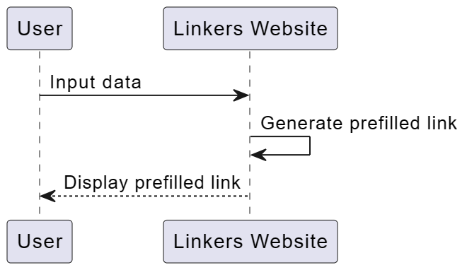

* Sure, let me explain the sequence diagram you provided:

1. User: Represents the user who interacts with the "Linkers Website" to perform some action.
2. "Linkers Website" as Website: Represents the website named "Linkers Website" where the user performs actions and interacts with.
3. User -> Website: Input data: This arrow indicates that the user provides input data to the website. This input data could be any information required by the website, such as a URL or text for generating a prefilled link.
4. Website -> Website: Generate prefilled link: This arrow represents an action within the website itself. After receiving the input data from the user, the website processes this data internally to generate a prefilled link. This step occurs within the website's backend or processing logic.
5. Website --> User: Display prefilled link: Once the prefilled link is generated by the website, it sends the result back to the user. This result is displayed to the user, typically in the form of a generated link that the user can use for their intended purpose.

* In summary, the sequence diagram illustrates the flow of interactions between the user and the "Linkers Website" for generating a prefilled link based on input data provided by the user.

**4.5 ER diagram**

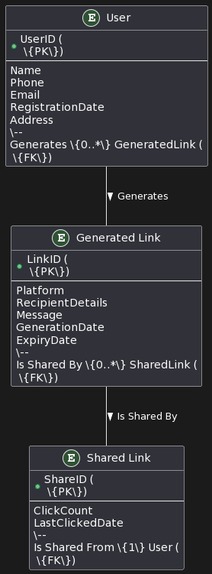

* In this detailed ER diagram:
* User: Represents the users of the Linkers Project. Each user has a unique UserID (Primary Key) and attributes such as Name, Phone, Email, RegistrationDate, and Address. The "User" entity generates zero or more "Generated Link" entities.
* Generated Link: Represents the pre-filled links generated by users. Each generated link has a unique LinkID (Primary Key) and attributes including Platform, RecipientDetails, Message, GenerationDate, and ExpiryDate. Each generated link can be shared multiple times, forming a relationship with the "Shared Link" entity.
* Shared Link: Represents instances when a generated link is shared. Each shared link has a unique ShareID (Primary Key) and attributes like ClickCount and LastClickedDate.

**4.6 Activity diagram**

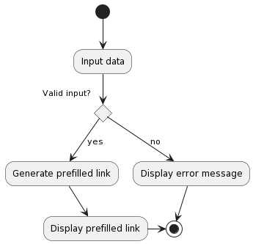

**Sure! Here's the explanation of how the activity diagram works:**

**1. **Input Data**: The process starts with the user inputting data into the system, which could be any required information for generating a prefilled link.**

**2. **Valid Input?**: After receiving the input, the system checks whether the input is valid or not.**

**3. **Valid Input (Yes)**: If the input is valid, the system proceeds to generate a prefilled link based on the input data.**

**4. **Generate Prefilled Link**: In this step, the system generates a prefilled link using the provided input data.**

**5. **Display Prefilled Link**: After generating the prefilled link, the system displays it to the user for further action or use.**

**6. **Invalid Input (No)**: If the input is not valid, the system takes an alternative path and displays an error message to the user.**

**7. **Display Error Message**: In case of invalid input, the system displays an error message indicating that the input provided by the user is not acceptable or needs correction.**

**8. **Loop Back**: After completing the generation and display of the prefilled link or showing the error message, the system loops back to the initial state to await further input from the user.**

**This activity diagram illustrates the flow of actions and decisions involved in the process of inputting data, validating it, generating a prefilled link, and providing feedback to the user based on the validity of the input.**

**4.7 Data dictionary / Database structure**

**User:**

|  |  |  |
| --- | --- | --- |
| Field | Data Type | Description |
| UserID (PK) | Integer | Unique identifier for users |
| Name | String | User's full name |
| Phone | String | User's phone number |
| Email | String | User's email address |
| RegistrationDate | Date | Date of user registration |
| Address | String | User's address |

**Generated Link:**

|  |  |  |
| --- | --- | --- |
| Field | Data Type | Description |
| LinkID (PK) | Integer | Unique identifier for generated links |
| Platform | String | Messaging platform (e.g., WhatsApp) |
| RecipientDetails | String | Details of the message recipient |
| Message | String | Message to be sent |
| GenerationDate | Date | Date when the link was generated |
| ExpiryDate | Date | Expiration date of the generated link |

**Shared Link:**

|  |  |  |
| --- | --- | --- |
| **Field** | **Data Type** | **Description** |
| ShareID (PK) | Integer | Unique identifier for shared links |
| ClickCount | Integer | Number of times the link was clicked |
| LastClickedDate | Date | Date and time of the last click on the link |
| UserID (FK) | Integer | Foreign key referencing User.UserID |
| LinkID (FK) | Integer | Foreign key referencing GeneratedLink.LinkID |

**4.8 Class Diagrams**

**4.9 Major Screenshot of the project**

* **Home Section:**
* 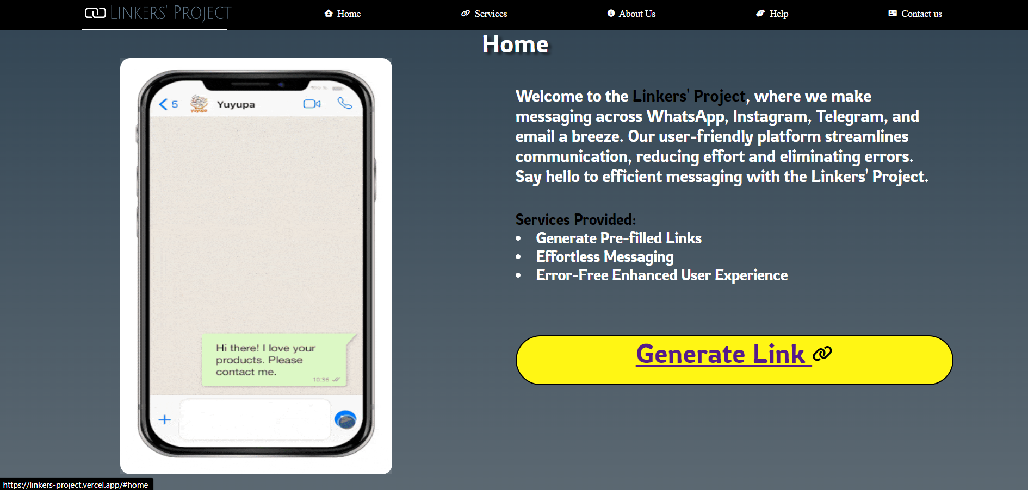
* **Services Section:**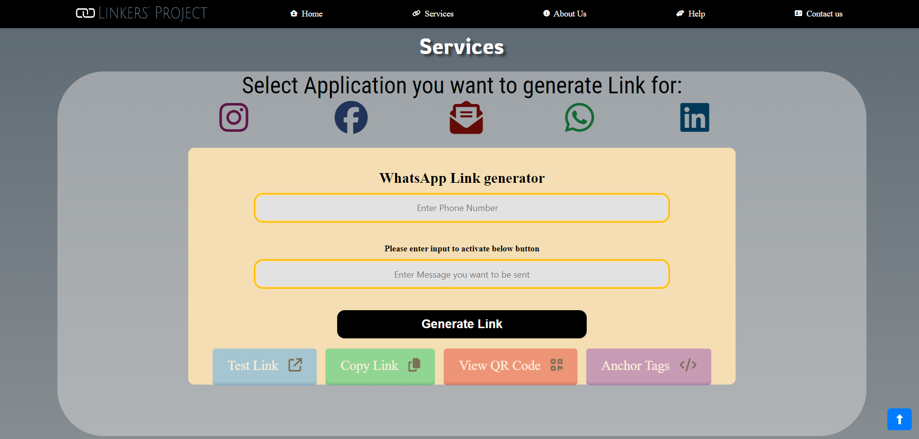
* **About Us Section:** 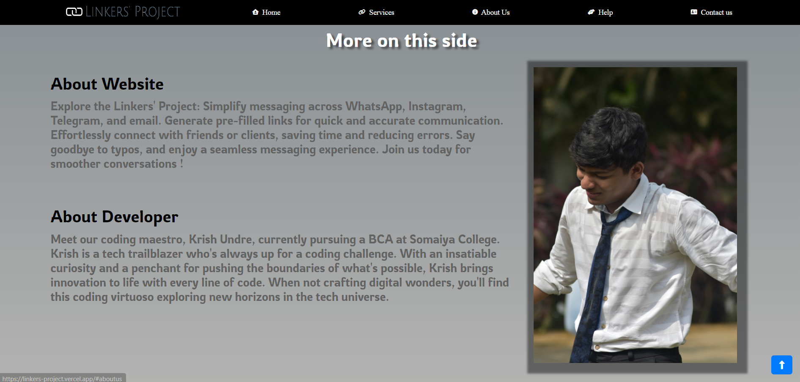
* **Help Section:** 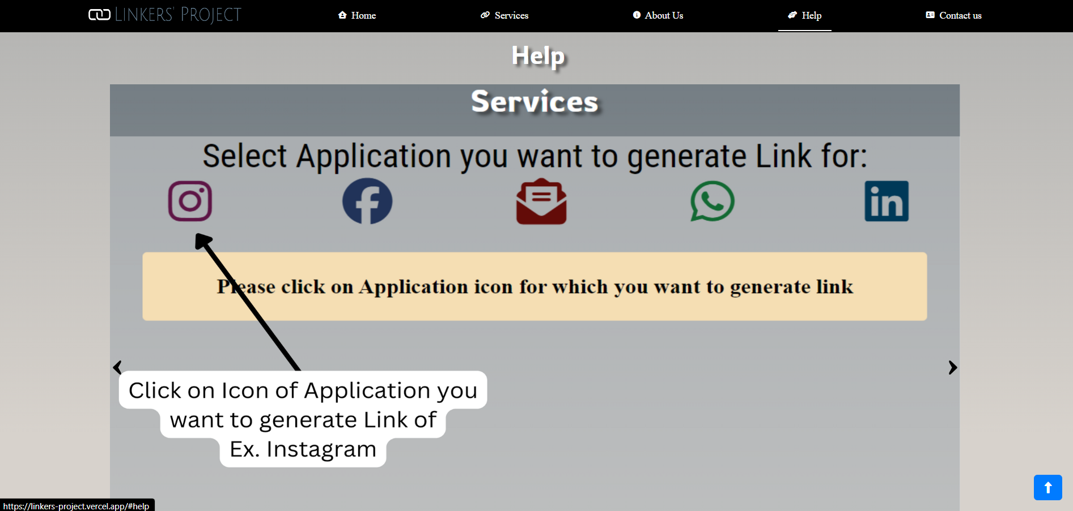
* **Contact Section:**
* 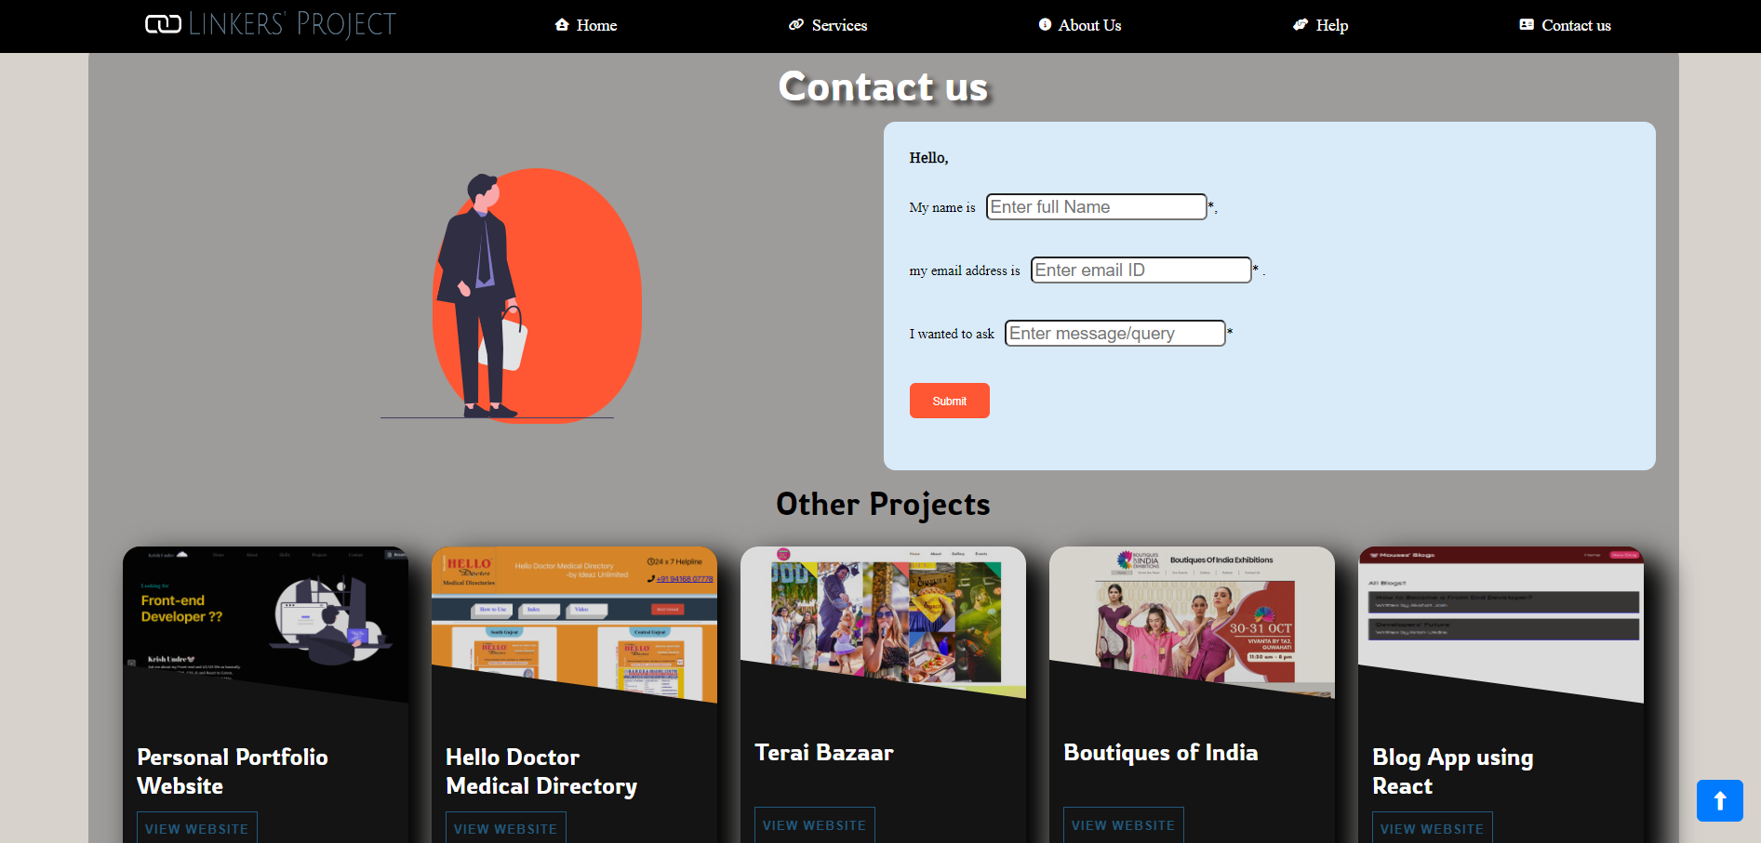

**Chapter - 5 Implementation & Testing**

* **5.1: Algorithms & Flowchart along with Major Modules of the Project**
* **5.2: Testing Approach**
* Test Case: User Registration
* Test Case ID: TC-001
* Test Objective: To verify that a user can successfully register on the "Linkers" website.
* Preconditions:
* 1. The "Linkers" website is accessible.
* 2. The user has not registered previously.
* Expected Result: The user should be able to register successfully and should be redirected to the login page.
* Test Result:
* - Actual Outcome: The user registration was successful.
* - Pass/Fail: Pass
* - Issues/Bugs: No issues encountered.
* ---
* Test Case: Invalid Login Credentials
* Test Case ID: TC-002
* Test Objective: To verify that the system does not allow login with invalid credentials.
* Preconditions:
* 1. The "Linkers" website is accessible.
* 2. The user has a registered account.
* Expected Result: The system should display an error message indicating that the login credentials are invalid, and the user should not be logged in.
* Test Result:
* - Actual Outcome: The system displayed an error message: "Invalid email or password."
* - Pass/Fail: Pass
* - Issues/Bugs: No issues encountered.
* ---
* Test Case: Generate QR Code
* Test Case ID: TC-003
* Test Objective: To verify that a user can generate a QR code for a given link on the "Linkers" website.
* Preconditions:
* 1. The user is logged in to the "Linkers" website.
* 2. The user has a link to generate a QR code for.
* Expected Result: The system should display the generated QR code for the provided link.
* Test Result:
* - Actual Outcome: The system displayed the generated QR code for the provided link.
* - Pass/Fail: Pass
* - Issues/Bugs: No issues encountered.
* ---
* Test Case: Generate Link with Incomplete Details
* Test Case ID: TC-004
* Test Objective: To verify that the system displays an error message when a user tries to generate a link without filling in all the required details.
* Preconditions:
* 1. The user is logged in to the "Linkers" website.
* 2. The user navigates to the link generation page.
* Expected Result: The system should display an error message indicating that all required details must be filled in to generate the link.
* Test Result:
* - Actual Outcome: The system displayed an error message: "Please fill in all required details."
* - Pass/Fail: Pass
* - Issues/Bugs: No issues encountered.
* ---
* Test Case: Copy Generated Link
* Test Case ID: TC-005
* Test Objective: To verify that the system successfully copies the generated link to the user's clipboard when they click on the "Copy Link" button.
* Preconditions:
* 1. The user is logged in to the "Linkers" website.
* 2. The user has generated a link on the website.
* Expected Result: The system should copy the generated link to the user's clipboard without any errors.
* Test Result:
* - Actual Outcome: After clicking on the "Copy Link" button, the system successfully copied the generated link to the user's clipboard.
* - Pass/Fail: Pass
* - Issues/Bugs: No issues encountered.
* ---
* **5.3 Test Case with Test Result**

| * **Test Case ID** | * **Test Case** | * **Expected Result** | * **Test Outcome** | * **Test Pass (Y/N)** |
| --- | --- | --- | --- | --- |
| * TC-001 | * User attempts to generate a link without filling in the required details. | * System should display an error message indicating that all required details must be filled in. | * Error message is displayed prompting user to fill in all required details. | * Y |
| * TC-002 | * User fills in all required details and successfully generates a link. | * System should generate a link based on the user's input data. | * Link is successfully generated and displayed to the user. | * Y |
| * TC-003 | * User clicks on the "Copy Link" button after generating a link. | * System should copy the generated link to the user's clipboard. | * Generated link is copied to the user's clipboard without any errors. | * Y |
| * TC-004 | * User attempts to generate a QR code without generating a link first. | * System should display an error message indicating that a link must be generated first. | * Error message is displayed prompting user to generate a link first. | * Y |
| * TC-005 | * User clicks on the "View QR Code" button after generating a link. | * System should display the QR code corresponding to the generated link. | * QR code is displayed to the user showing the generated link. | * Y |

**Chapter - 6 Result & Discussion**

* **6.1: Summary of Test Reports**
* Here's a summary of the test cases conducted for the Linkers project:
* 1. **Test Case 1 (TC-001):** Validates the system's response when the user attempts to generate a link without filling in the required details. The test outcome confirms that the system appropriately prompts the user to fill in all necessary information.
* 2. **Test Case 2 (TC-002):** Ensures that the system successfully generates a link when the user fills in all required details. The test outcome confirms that the link is generated and displayed correctly to the user.
* 3. **Test Case 3 (TC-003):** Verifies the system's functionality to copy the generated link to the user's clipboard when the "Copy Link" button is clicked. The test outcome confirms that the link is copied to the clipboard without any issues.
* 4. **Test Case 4 (TC-004):** Tests the system's response when the user attempts to generate a QR code without generating a link first. The test outcome confirms that the system appropriately prompts the user to generate a link before proceeding.
* 5. **Test Case 5 (TC-005):** Validates the system's capability to display the QR code corresponding to the generated link when the "View QR Code" button is clicked. The test outcome confirms that the QR code is displayed correctly to the user, reflecting the generated link.
* These test cases cover various scenarios and functionalities of the Linkers project, ensuring that the system behaves as expected and meets the specified requirements.
* **6.2: Discussion**
* Here's a discussion of the tests conducted for the Linkers project:
* 1. **Test Case 1 (TC-001):**
* - Test Objective: This test verifies the system's response when the user attempts to generate a link without providing all the required details.
* - Discussion: By intentionally leaving out essential information and trying to generate a link, the system appropriately prompts the user to fill in all necessary details before proceeding. This ensures that users are guided to provide the required inputs and prevents incomplete or erroneous link generation.
* 2. **Test Case 2 (TC-002):**
* - **Test Objective:** This test ensures that the system successfully generates a link when all required details are provided by the user.
* - **Discussion:** By inputting all necessary information and initiating the link generation process, the system generates and displays the link accurately. This test confirms that the system functions as intended and provides the expected output when users complete the required steps.
* 3. **Test Case 3 (TC-003):**
* - **Test Objective:** This test verifies the system's ability to copy the generated link to the user's clipboard upon request.
* - **Discussion:** When users click the "Copy Link" button, the system copies the generated link to their clipboard, allowing for easy sharing or pasting into other applications. This functionality enhances user experience and facilitates seamless interaction with the generated content.
* 4. **Test Case 4 (TC-004):**
* - **Test Objective:** This test examines the system's response when the user tries to generate a QR code without generating a link first.
* - **Discussion:** By attempting to view the QR code without generating a link, the system prompts the user to generate a link first, preventing any attempt to create a QR code without a valid link. This validation ensures that users follow the correct sequence of actions and prevents errors or inconsistencies in the system.
* 5. **Test Case 5 (TC-005):**
* - **Test Objective:** This test validates the system's capability to display the QR code corresponding to the generated link.
* - **Discussion:** When users request to view the QR code, the system displays the QR code accurately, representing the generated link. This feature enables users to access the link conveniently using QR code scanning applications, enhancing accessibility and usability.
* Overall, these tests cover critical functionalities of the Linkers project, ensuring that the system operates smoothly, provides the expected outputs, and offers a satisfactory user experience.

**Chapter – 7 Conclusion**

* **7.1: Conclusion of the Project**
* 1. Summary of Project:
* The project aimed to streamline the process of generating links, QR codes, and anchor codes for various social media platforms. By integrating frontend technologies like HTML, CSS, and JavaScript with MySQL as the backend database, the website provided users with a user-friendly interface to perform these tasks efficiently.
* 2. Achievements:
* Significant milestones were achieved throughout the project, including the successful implementation of dynamic features like link generation and QR code creation. The project also demonstrated effective collaboration among team members and adherence to project timelines.
* 3. Technological Impact:
* The project showcased the innovative use of frontend and backend technologies to address user needs effectively. By leveraging modern web development tools and techniques, the project demonstrated the potential for technology to enhance user experiences and simplify complex tasks.
* 4. User Benefits:
* Users benefited from the project by gaining access to a comprehensive platform for generating links, QR codes, and anchor codes seamlessly. The website's intuitive interface and robust functionality empowered users to create and share content effortlessly across various social media platforms.
* 5. Future Scope:
* Potential future enhancements include the integration of additional social media platforms, improved user authentication mechanisms, and enhanced customization options for generated content. These enhancements would further enrich the user experience and expand the project's capabilities.
* 6. Acknowledgments:
* We extend our gratitude to all team members, stakeholders, and mentors who contributed to the success of the project. Their dedication and support were invaluable in achieving our goals and delivering a high-quality product.
* 7. Conclusion Statement:
* In conclusion, the project has made significant strides in simplifying link generation and enhancing user engagement on social media platforms. By leveraging cutting-edge technologies and fostering collaboration, the project has paved the way for future innovation and development in this space.
* **7.2: Limitation of the Project**

Despite its successes, the project has encountered several limitations that warrant consideration:

* **Platform Dependency:**

The project's functionality is contingent on the availability and compatibility of web browsers and internet connectivity. Users may experience limitations or inconsistencies based on their chosen platform or device, impacting the overall user experience.

**2. Scalability Challenges:**

As the user base and data volume grow, the project may encounter scalability challenges related to database performance, server capacity, and resource allocation. Scaling the infrastructure to accommodate increased demand requires careful planning and implementation to ensure uninterrupted service.

**3. Security Vulnerabilities:**

The project may be susceptible to security vulnerabilities such as cross-site scripting (XSS), SQL injection, and data breaches. Ensuring robust security measures, such as encryption, authentication mechanisms, and regular security audits, is essential to safeguard user data and protect against cyber threats.

**4. User Adoption and Engagement:**

Driving user adoption and engagement poses a challenge, particularly in competitive market environments where alternative solutions may exist. Strategies for marketing, user acquisition, and retention must be carefully crafted to attract and retain users effectively.

**5. Regulatory Compliance:**

Adhering to regulatory requirements, such as data protection laws (e.g., GDPR, CCPA), privacy policies, and industry standards, presents a significant challenge. Failure to comply with regulatory mandates can result in legal consequences, reputational damage, and loss of user trust.

**6. Technical Constraints:**

The project's development may be constrained by technical limitations, including compatibility issues with legacy systems, software dependencies, and API restrictions. Overcoming these constraints requires innovative solutions and effective collaboration among development teams.

**7. Resource Constraints:**

Limited financial resources, manpower, and time constraints may impede the project's progress and development efforts. Prioritizing tasks, allocating resources efficiently, and leveraging available tools and technologies can help mitigate these challenges.

**8. Feedback and Iteration:**

Gathering user feedback and iterating on the project based on evolving user needs and market trends is essential for long-term success. However, limited feedback channels or ineffective feedback mechanisms may hinder the project's ability to adapt and evolve over time.

**Conclusion:**

While the project has demonstrated considerable promise and potential, addressing these limitations requires ongoing effort, strategic planning, and collaboration. By acknowledging and mitigating these challenges, the project can continue to evolve and thrive in an ever-changing technological landscape.

* **7.3: Future Scope of the Project**

The project holds significant potential for expansion and enhancement in several key areas:

1. **Feature Enrichment:**

Continuously enriching the project with new features and functionalities can enhance its value proposition and attract a broader user base. Features such as advanced link customization options, integration with additional social media platforms, and real-time analytics can further differentiate the project from competitors.

**2. Mobile Optimization:**

Optimizing the project for mobile devices and developing dedicated mobile applications can extend its reach to users who primarily access the internet via smartphones and tablets. Mobile optimization can improve user experience, accessibility, and engagement, thereby increasing user retention and satisfaction.

**3. Personalization and Customization:**

Introducing personalized user experiences and customization options can enhance user satisfaction and loyalty. Implementing features such as user preferences, saved templates, and personalized recommendations based on user behavior and preferences can create a more tailored and engaging user experience.

**4. Monetization Strategies:**

Exploring diverse monetization strategies, such as premium subscriptions, advertising, affiliate marketing, and sponsored content, can generate additional revenue streams for the project. Developing strategic partnerships with brands, influencers, and advertisers can unlock new revenue opportunities while providing value to users.

**5. Internationalization and Localization:**

Expanding the project's reach to international markets by supporting multiple languages, currencies, and cultural preferences can facilitate global adoption and growth. Localization efforts, including translation, cultural adaptation, and region-specific features, can cater to diverse user demographics and preferences worldwide.

**7. Community Building and Engagement:**

Fostering a vibrant and engaged user community through forums, social media channels, and user-generated content can strengthen brand loyalty and advocacy. Implementing community-building initiatives, such as contests, events, and user feedback programs, can cultivate a sense of belonging and ownership among users.

**8. Continuous Improvement and Optimization:**

Embracing a culture of continuous improvement and optimization through regular updates, bug fixes, and performance enhancements is essential for maintaining competitiveness and relevance in the dynamic digital landscape. Conducting regular usability testing, performance monitoring, and user feedback analysis can inform iterative improvements and ensure that the project evolves in line with user expectations and market trends.

By capitalizing on these future opportunities and embracing innovation and adaptability, the project can position itself for sustained growth, differentiation, and success in the ever-evolving digital ecosystem.

**Reference**

* Mozilla Developer Network. (n.d.). HTML: Hypertext Markup Language. Retrieved from [<https://developer.mozilla.org/en-US/docs/Web/HTML>]
* W3Schools. (2023). CSS Tutorial. Retrieved from [<https://www.w3schools.com/css/>]
* JavaScript | MDN. (n.d.). Mozilla Developer Network. Retrieved from [<https://developer.mozilla.org/en-US/docs/Web/JavaScript>]
* MySQL :: MySQL Documentation. (n.d.). MySQL. Retrieved from [<https://dev.mysql.com/doc/>]
* GitHub. (2023). GitHub: Where the world builds software. Retrieved from [<https://github.com/>]
* QRCode.js. (2023). GitHub Repository. Retrieved from [<https://github.com/davidshimjs/qrcodejs>]
* Figma: the collaborative interface design tool. (n.d.). Figma. Retrieved from [<https://www.figma.com/>]
* SeleniumHQ Browser Automation. (n.d.). Selenium. Retrieved from [<https://www.selenium.dev/>]
* CodePen. (n.d.). CodePen: Online Code Editor and Front End Web Developer Community. Retrieved from [<https://codepen.io/>]

**Annexure**